**GIT Repository**

<https://github.com/yanngilbert-one/CSC500-1/tree/main/Assignment%20Week%204>

**Pseudocode**

[main.py](http://main.py)

BEGIN main

SET item_list

SET next_item_input = yes

WHILE next_item_input = yes

item = resources.get_user_input

item_list.append(item)

GET next_item_input

DISPLAY items_in_list

DISPLAY total_cost

END main

[resources.py](http://resources.py)

FUNCTION get_user_item

SET valid_input = False

GET item_name

WHILE NOT valid_input

TRY

GET item_price

IF item_price < 0

DISPLAY error_message

ELSE

valid_input = True

break

CATCH

DISPLAY error_message

SET valid_input = False

WHILE NOT valid_input

TRY

GET item_quantity

IF item_quantity<0

DISPLAY error_message

ELSE

valid_input = True

break

CATCH

DISPLAY error_message

RETURN ItemToPurchase(item_name, item_price, item_quantity)

item_to_purchase.py

CLASS ItemToPurchase

FUNCTION __init__(self, item_name = “none”, item_price = 0, item_quantity = 0)

self.item_name = item_name

self.item_price = item_price

self.item_quantity = item_quantity

FUNCTION print_item_cost(self)

CALCULATE total_cost

DISPLAY item_name, item_quantity, item_price, total-cost

RETURN total_cost

**Source Code**

[main.py](http://main.py)

import resources

#initialize item list array as well as validation for the loop handling if user would like to continue or stop inputing items

item_list = []

next_item_input = "yes"

#loop to build item list array

while next_item_input.lower() == "yes":

#get user item data from user

item = resources.get_user_item()

#add item to list of items

item_list.append(item)

#ask user if continuing to input items

next_item_input = input("Would you like to add another item? (yes/no): ")

#print total cost of cart

print("\n--- Items in your list: ---")

total_cost = sum(item.print_item_cost() for item in item_list)

print(f"\nTotal cost of all ({len(item_list)}) items in cart: ${total_cost:.2f}")

[resources.py](http://resources.py)

#import ItemToPurchase class

from item_to_purchase import ItemToPurchase

#function to get and validate all item data from user

def get_user_item():

#input validation variable

valid_input = False

#get item name, no validation needed here. In a real scenario we would put a character limit of some sort here and security features like SQL injection protection

item_name = input("Enter the item name: ")

#loop until data input is valid

while not valid_input:

try:

#converting input to float

item_price = float(input("Enter the item price: "))

#if item price is less than 0, it must be negative and therefor not acceptable input

if item_price < 0:

print("Price cannot be negative, please enter a positive value for the price.")

else:

#validate input and exit loop

valid_input = True

break

#if value conversion to float is not valid, throw error and display error message

except ValueError:

print("Invalid value. Please enter a positive numerical value.")

#input validation variable

valid_input = False

#loop until data input is valid

while not valid_input:

try:

#converting input to int

item_quantity = int(input("Enter the item quantity: "))

#if item quantity is less than 0, it must be negative and therefor not acceptable input

if item_quantity < 0:

print("Quantity cannot be negative, please enter a positive value for the quantity.")

else:

#validate input and exit loop

valid_input = True

break

#if value conversion to int is not valid, throw error and display error message

except ValueError:

print("Invalid value. Please enter a positive integer without any decimals, quantity cannot be a decimal value, you cannot buy a third of an item!")

#return item with its attributes

return ItemToPurchase(item_name, item_price, item_quantity)

item_to_purchase.py

#initialize class

class ItemToPurchase:

#constructor

def __init__(self, item_name = "none", item_price = 0, item_quantity = 0):

self.item_name = item_name

self.item_price = item_price

self.item_quantity = item_quantity

#function to print item cost using all attributes

def print_item_cost(self):

total_cost = self.item_price * self.item_quantity

print(f"{self.item_name} {self.item_quantity} @ ${self.item_price:.2f} = ${total_cost:.2f}")

return total_cost

**Test Cases (Screenshots)**

Case 1: Success

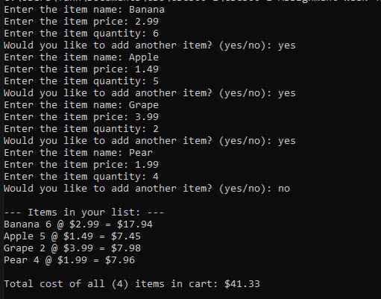

Case 2: Invalid price (negative value or not a numeral)

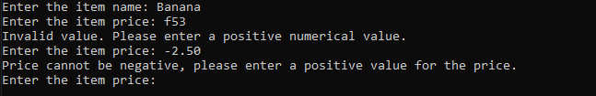

Case 3: Invalid quantity (negative value or not an integer)

